1. **Command**🡺 setting embedded/nested document.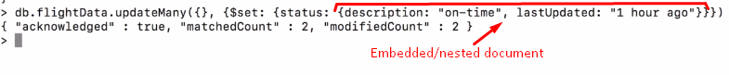
2. 